Assessment Schedule – 2013
Mathematics and Statistics: Apply calculus methods in solving problems (91262)
Evidence Statement
ONE |  | Achievement | Merit | Excellence
 |  | Apply calculus methods in solving problems. | Apply calculus methods, using relational thinking, in solving problems. | Apply calculus methods, using extended abstract thinking, in solving problems.
(a) | f '(x) = 8x – 5  f '(3) = 19 | Derivative found and gradient found.
(b) | 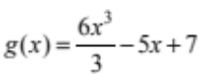 | Anti-derivative and function found  OR equivalent.
(c) | h'(t) = 90 – 10t = 0  t = 9  h(9) = 407 | Derivative found and equated to 0. | Time for maximum and the height found.  Units not required.
(d) | g'(t) = –0.01t + 0.15  = 0.04  t = 11 | Derivative found and equated to 0.04. | Time calculated.  Units not required.
(e) | g'(x) = –3x² + 3 = 0  3(1 + x)(1 – x) = 0  x = –1, 1  x < –1, x > 1  Check gradient:  g'(0) = 3 > 0  increasing.  OR shape of graph  –ve cubic. | Derivative found  and = 0 or < 0. | x values of turning point found. | Regions correctly identified and justified.
(f) | 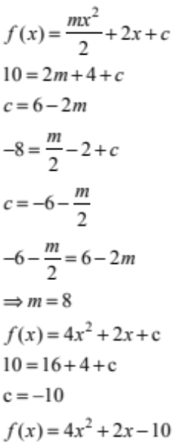 | Equation found in terms of m and equated to 10. | Value of m or c found. | Equation of curve found.

NØ no response; no relevant evidence
N1 attempt at one question
N2 1 of u
A3 2 of u
A4 3 of u
M5 1 of r
M6 2 of r
E7 1 of t
E8 2 of t

Evidence Statement

TWO |  | Achievement | Merit | Excellence
(a) | 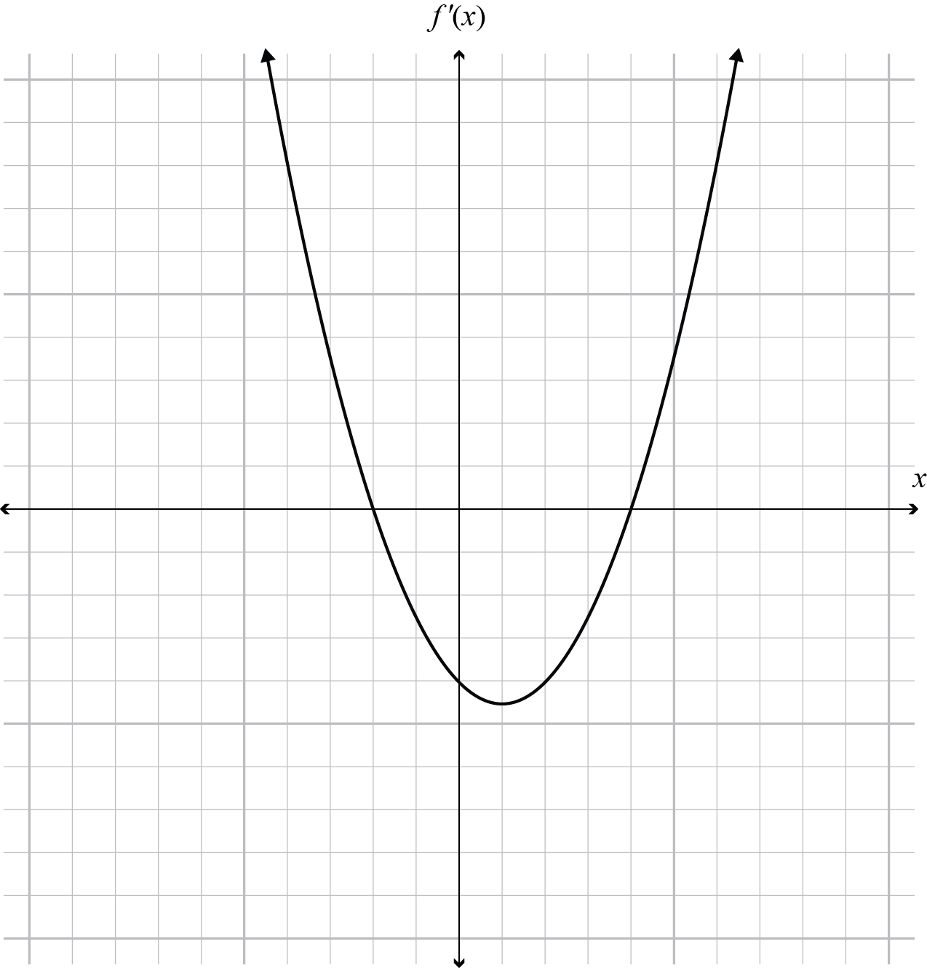 | Correct curve and x intercepts, and y intercept negative.
(b) | 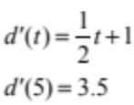 | Derivative and rate found.  Units not required
(c) | 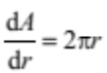  For given area r = 7  Rate of change = 14π or 43.99. | Derivative found and attempt to find r using the correct equation. | r found and rate of change calculated.
(d) | 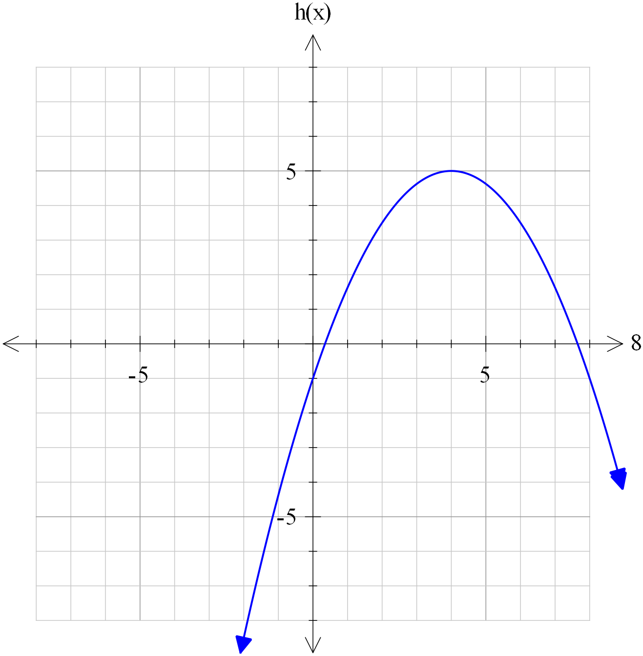 | –ve parabola. | Negative parabola with maximum at (4,5). | Correct parabola and passing through  intercept (0,–1).
(e) | 6x² – 12x = 0  6x(x – 2) = 0  x = 0, 2 Min at x = 2  Hence passes through (2,10)  y = 2x³ – 6x² + c  10 = 2 × 8 – 24 + c  c = 18  y = 2x³ – 6x² + 18 | x values of turning points identified.  OR  Correct integration set equal to 10. | Minimum turning point at  x = 2 identified and justified and the point (2,10) use | Equation of curve found.
(f) | v = –0.04t² + c  5 = –0.04 × 3² + c c = 5.36  s = 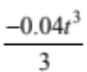 + 5.36t + c  c = 0  –0.04t² + 5.36 = 0  t² = 134  t = 11.58  s(11.58) = 41.4 | Velocity function formed. | Distance function formed. | Distance found.
NØ no response; no relevant evidence
N1 attempt at one question
N2 1 of u
A3 2 of u
A4 3 of u
M5 1 of r
M6 2 of r
E7 1 of t
E8 2 of t
Evidence Statement

THREE |  | Achievement | Merit | Excellence
(a) | f(x) = 2x² + 3x + c  c = 0  f (–3) = 9  Hence (–3,9) | Anti-derivative given and point found.
(b)(i) | g'(x) = x – 5 = 2  x = 7 | Gradient function and solution found.
(b)(ii) | g'(8) = 8 – 5 = 3  y + 8 = 3(x – 8)  y = 3x – 32 |  | Equation of tangent formed.
(c) | 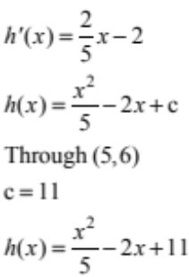 | Equation of line found and anti-differentiated. | Equation of curve given  OR equivalent.
(d) | f '(x) = 2Px + Q = 0  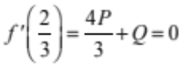  9 = P + Q + 2  Q = 7 – P  P = –21  Q = 28  f(x) = –21x² + 28x + 2  f(3) = –103  Hence (3,–103) | Derivative found and equated to 0. | P or Q calculated. | P and Q found and coordinates calculated.
(e) | 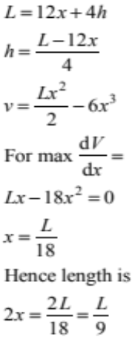 0 | Attempted to find an equation in one variable and successfully differentiated. | Equation for volume found and differentiated and set equal to 0. | Found the value for x,  ie 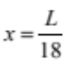

NØ no response; no relevant evidence
N1 attempt at one question
N2 1 of u
A3 2 of u
A4 3 of u
M5 1 of r
M6 2 of r
E7 1 of t
E8 2 of t

Judgement Statement
 | Not Achieved | Achievement | Achievement  with Merit | Achievement  with Excellence
Score range | 0 – 7 | 8 – 14 | 15 – 19 | 20 – 24

